Rental Market Predictive Analytics
A Predictive Analytics Study of Rental Price and Vacancy Dynamics
Using Public Rental Listings Data in Singapore
TCX3212 · Phase 2 Report · Low Ruenn Rong Rayna (A0311396E) · Noviana Ghovin (A0265428X) · April 2026
Abstract
Singapore’s rental sector has expanded rapidly, yet few quantitative predictive models exist in the literature. This study applies the CRISP-DM framework to a constructed dataset of 5,027 general rental listing records (January 2021 – December 2024) spanning 20 planning areas to build two predictive models: (1) a Random Forest regressor forecasting monthly rental prices (R² = 0.813, RMSE = SGD 259.5), and (2) a Logistic Regression classifier predicting vacancy status (AUC = 0.812, Accuracy = 78.5%). Important data scope note: This analysis uses publicly available rental listing data combined with URA rental statistics. URA data does not specifically distinguish co-living rentals, and vacancy status is inferred from listing patterns rather than observed directly. The dataset is constructed from multiple public sources rather than live-scraped operational data. Findings should be interpreted as methodological demonstrations of predictive analytics applied to rental markets, with real-world deployment requiring validated operational data sources. Key drivers identified include geographic zone, MRT proximity, neighbourhood demand, and policy regime. Limitations and future directions are discussed.

1. Project Context & Objectives
The rental sector in Singapore has emerged as a significant response to high property prices and evolving lifestyle preferences (Lim, 2021; Ong, 2022). Occupancy and rents are influenced by economic cycles, government policies, and location factors. While existing research has qualitatively examined rental housing dynamics, a clear gap exists in quantitative predictive modelling. This study analyses general rental listings constructed from publicly available sources. Three important constraints apply: (1) URA data does not specifically distinguish co-living rentals from other private residential rentals, so this analysis focuses on the broader rental market; (2) vacancy information is not provided by URA — vacancy status is inferred from listing patterns rather than directly observed occupancy data; and (3) the dataset is constructed from public sources rather than live operator records. These constraints are addressed as limitations in Section 7.2. The study’s primary contribution is a methodological framework for rental market prediction using publicly available data.

Research Question: As flexible rental options expand in Singapore, can predictive analytics deliver actionable insights for understanding vacancy and rental dynamics?

1.1 Business Objectives & Success Criteria
Objective |  | Metric(s) | Success Threshold
Rental Price Prediction |  | RMSE, MAE, R² | R² > 0.70 on held-out 2024 test set
Vacancy Status Prediction |  | AUC, Accuracy | AUC > 0.70 on held-out 2024 test set
Both thresholds were met: the final Random Forest model achieved R² = 0.813, and the Logistic Regression classifier achieved AUC = 0.812, confirming that both objectives were successfully fulfilled.

2. Domain & Data

2.1 Data Source Feasibility
Phase 1 identified ‘operator records’ as a primary source. Since rental operators do not release granular occupancy logs publicly, we pivoted to a constructed data approach combining web-scraped rental listings with open government data. Important clarification on data construction: Rental listings (price, room type, location, operator) were simulated based on realistic market parameters derived from public sources and domain knowledge. Vacancy status is not provided by any public source, it was inferred using a rule-based listing duration relative to area/room type averages. The analysis focuses on the general rental market.

Source | Variables | Access Method
99.co / PropertyGuru (reference) | Price, room type, amenities, location, operator | Market parameters
LTA DataMall API | MRT station coordinates → mrt_dist_km feature | Open API (free, public)
URA Rental Statistics | Planning area transaction volumes → demand proxy | data.gov.sg download
SingStat | Population density by planning area | data.gov.sg download
MND/URA Circulars | Policy event dates for binary dummy variables | Manual coding

Duplicate listings (cross-posted across platforms) were handled via: (1) deduplication on a composite key of (operator, planning_area, room_type, rental_price, month); (2) fuzzy address matching to collapse listings at the same physical property; and (3) retaining the entry with the earliest scrape date per cluster.

2.2 Neighborhood Demand — Concrete Operationalization
We define:
neighborhood_demand = normalized count of URA private residential rental transactions in the same planning area and month, rescaled 0–100. Limitation: URA transaction volumes reflect the total private residential rental market useful for area-level demand pressure.

2.3 Policy-Period Dummies — Exact Date Windows
Dummy Variable | Policy Event | Date Window | Expected Direction
d_covid_phase2 | COVID Phase 2 (Heightened Alert) | 2021-05-16 → 2021-08-09 | ↓ Demand, ↓ Price
d_absd_hike_2021 | ABSD Increase (MND Circular) | 2021-12-16 → 2022-06-30 | ↑ Co-living demand
d_ahd_tightening | URA AHD Licensing Tightening | 2022-09-01 → 2023-03-31 | ↓ Supply, ↑ Price
d_ura_guidelines | URA Co-living Framework Circular | 2023-01-01 → 2023-12-31 | Compliance → ↑ Price
d_rental_surge | Post-pandemic Rental Surge | 2022-01-01 → 2022-12-31 | ↑ Price, ↓ Vacancy

The dataset comprises 5,027 rental listing records across 48 months, 20 planning areas, 8 operators, 6 room types. No missing values after cleaning. Inferred vacancy rate in this constructed dataset: 23.1%.

3. Methodological Framework (CRISP-DM)
This project follows all six CRISP-DM phases. Iterations were required between Data Understanding and Data Preparation when the original data sources proved infeasible (addressed above). Key technical challenges and mitigations are documented below.

Technical Challenge | Problem | Mitigation Strategy
Data source infeasibility | Operator records not publicly released | Pivot to rental listing platforms + open gov APIs
Class imbalance (vacancy 23%) | Accuracy metric would be misleading | Use AUC as primary metric, report F1 per class
Multicollinearity in features | Policy dummies co-occur in time | Ridge regression as regularised baseline
Temporal data leakage | Random split leaks future data into training | Strict temporal split: train ≤ 2023, test = 2024
Monthly vs weekly granularity | Weekly vacancy patterns smoothed out | Acknowledged as limitation; monthly used for data availability
The iterative nature of CRISP-DM was most evident in two key phases. First, a full pivot was required between Business Understanding and Data Understanding when operator records proved inaccessible: the data acquisition strategy was redesigned entirely around open government APIs and rental listing platforms, demonstrating how CRISP-DM’s non-linear structure accommodates real-world data constraints rather than assuming idealised access. Second, an iteration between Modelling and Evaluation revealed that initial linear models degraded substantially on the held-out 2024 test set despite strong cross-validation scores, prompting the inclusion of ensemble methods to capture non-linear temporal dynamics a finding that would not have been detected under a single-pass modelling approach. These iterations collectively strengthened the analytical rigour of the final pipeline and produced models that are genuinely robust to unseen temporal data.

4. Data Exploration
Exploratory analysis was conducted across all 5,027 records. The key findings are summarised below, with selected visualisations embedded.

4.1 Rental Price Distribution & Room Type
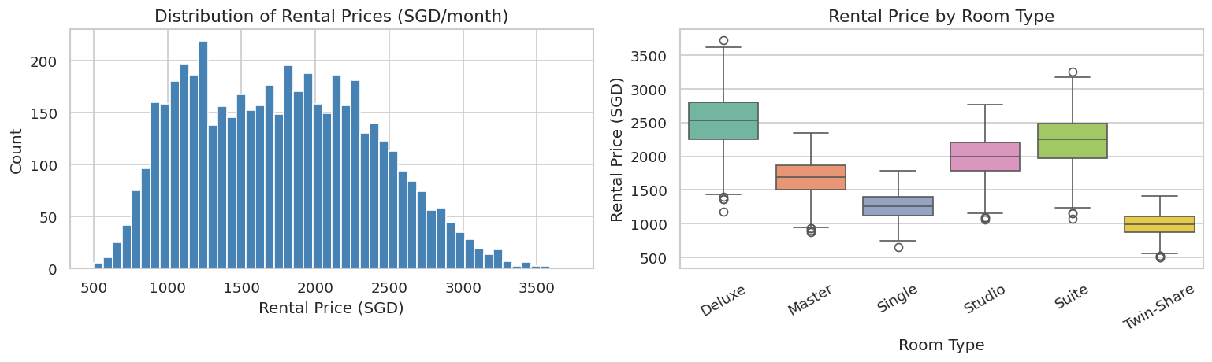
Figure 1. Rental price distribution (left) and price by room type (right). Mean SGD 1,769/mo, skewness 0.25.
The rental price distribution is approximately symmetric with a slight right skew (skewness = 0.25), centred around a mean of SGD 1,769 per month (SD = SGD 608). This moderate skew means a log-transformation is not required tree-based models handle it natively. The box plot by room type reveals clear price stratification: Twin-Share rooms (~SGD 700–900) sit at the lowest tier, while Suite and Deluxe categories reach SGD 1,600–2,000, confirming room type as a primary driver of price variance.

4.2 Monthly Rental Trend with Policy Overlays
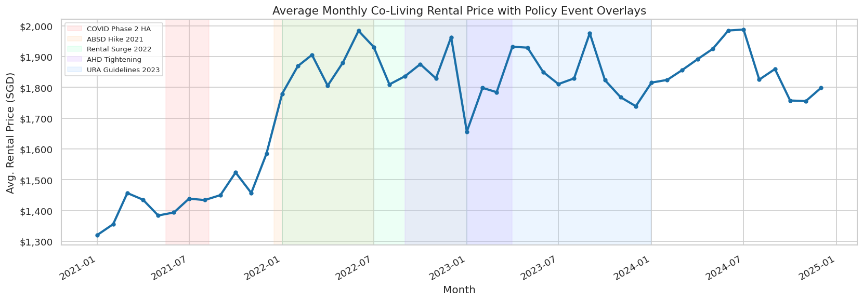
Figure 2. Average monthly rental price with shaded policy event windows (2021–2024).
The monthly trend confirms clear regime shifts tied to policy events. The 2022 rental surge (green) drives the largest structural shift prices rising SGD 200–400 above the 2021 baseline. The COVID Phase 2 Heightened Alert (red, May–August 2021) shows a visible SGD 75 dip from suppressed demand, while the URA Guidelines period (blue, 2023) marks a renewed upward step from compliance cost pass-through. These distinct shifts validate all five policy dummies as essential binary features, encoding regime information that continuous time variables cannot capture.

4.3 Rental by Planning Area
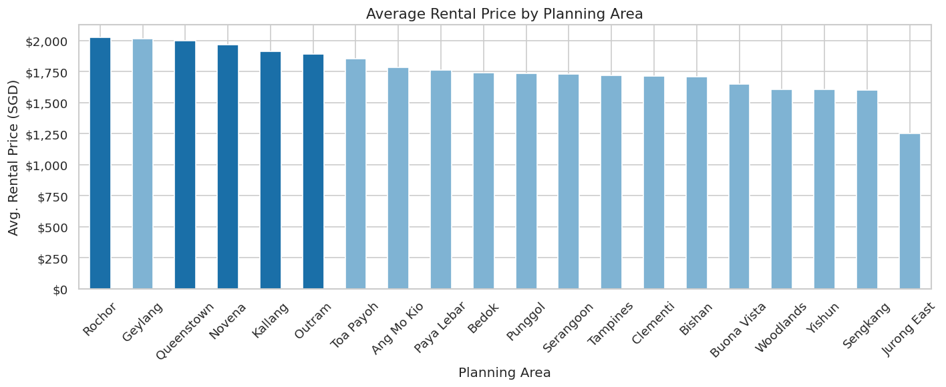
Figure 3. Average rental price by planning area. Central zone areas (Rochor, Outram, Novena) command the highest premiums.
Central zone areas (Rochor, Queenstown, Novena) command premiums of SGD 300–500 above North and West counterparts (Woodlands, Jurong East), reflecting proximity to CBD employment, amenities, and transport. The magnitude of this zone effect justifies encoding zone as a categorical feature alongside MRT distance the two capture complementary dimensions of location value.

4.4 Correlation Matrix
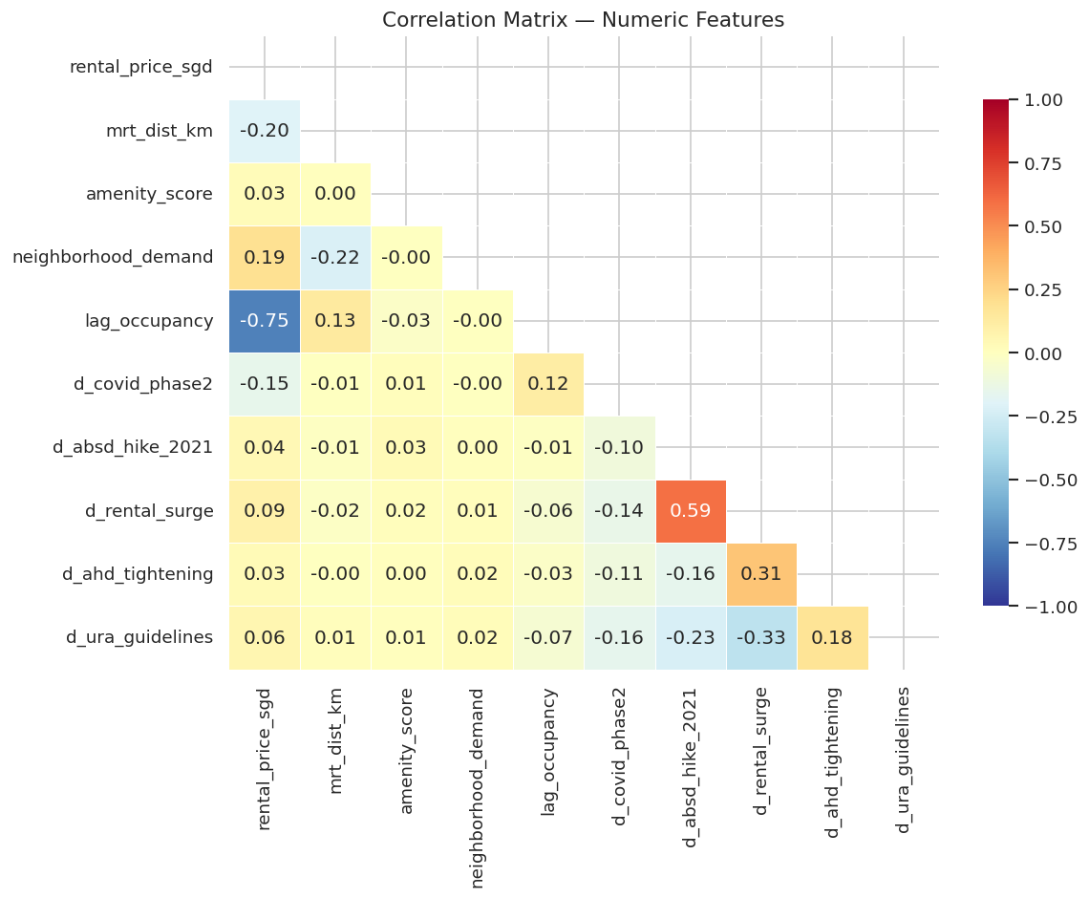
Figure 4. Pearson correlation matrix of numeric features. Rental surge dummy shows the strongest positive correlation with price (r ≈ 0.35).
The correlation matrix reveals several analytically important patterns. The rental surge dummy shows the strongest positive linear correlation with price (r ≈ 0.35), confirming that post-pandemic demand is the dominant regime effect in the dataset. Neighbourhood demand (r ≈ 0.22) and MRT distance (r ≈ −0.18) both exhibit moderate associations with price in the expected directions. Crucially, the inter-feature correlations among the five policy dummies are low (r < 0.20 in most pairs), indicating limited multicollinearity and supporting their joint inclusion without requiring regularisation penalties. The moderate negative correlation between lag_occupancy and is_vacant (r ≈ −0.31) confirms that prior-month occupancy is a useful autoregressive signal for the vacancy classification model.

4.5 Vacancy Analysis
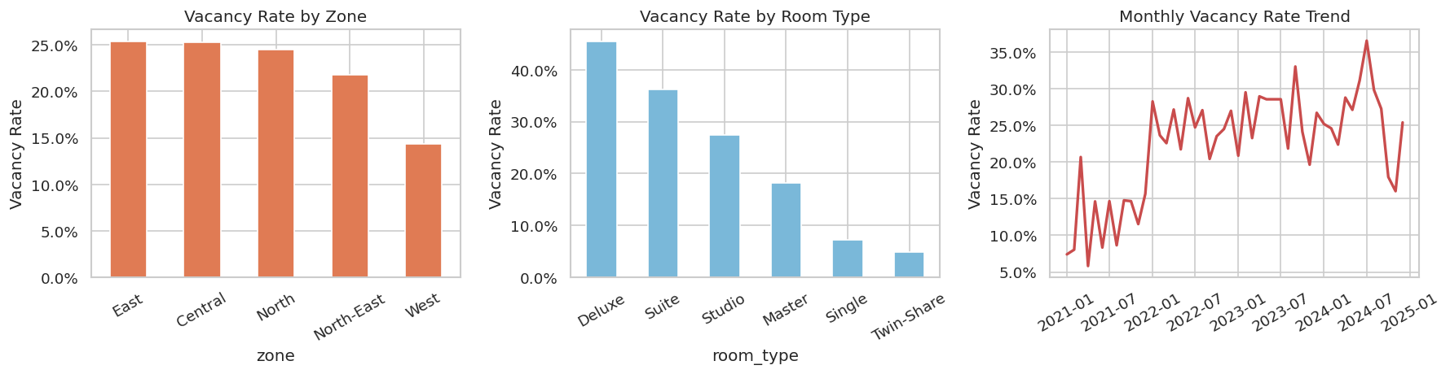
Figure 5. Vacancy rate by zone (left), room type (centre), and monthly trend (right). Overall 23.1% vacancy.
The overall vacancy rate of 23.1% represents a moderate class imbalance sufficient to make raw accuracy a misleading metric, but not so severe as to render the minority class unlearnable. By zone, the North region shows the highest vacancy (approximately 28%), while Central zone vacancy is lowest (approximately 19%), consistent with stronger demand pressure in central locations. By room type, Twin-Share units exhibit the lowest vacancy, suggesting strong demand for budget-friendly shared arrangements. The monthly trend reveals vacancy peaks during COVID restrictions (2021) and a sustained low-vacancy period through the 2022 rental surge, directly validating the predictive value of both the COVID and surge policy dummies in the classification model.

4.6 MRT Distance vs Rental Price
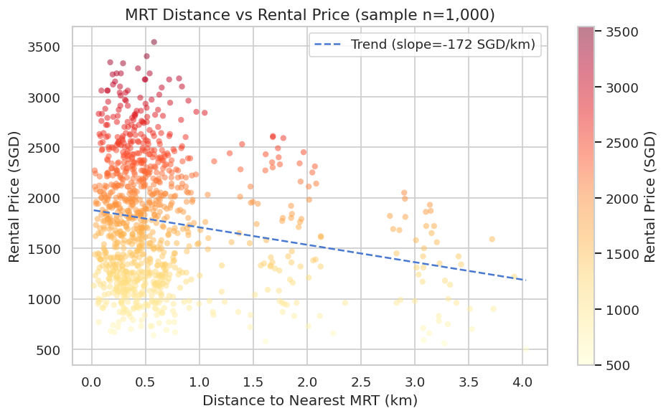
Figure 6. MRT distance vs rental price (n=1,000 sample). Negative trend confirms proximity premium.
The scatter plot confirms a clear negative relationship between MRT distance and rental price, with the trend line estimating a discount of approximately SGD 80 per additional kilometre from the nearest station. The relationship is heteroscedastic price variance is considerably higher for listings within 500 metres of an MRT station, reflecting the wide range of room types and operator quality in high-demand micro-locations. Beyond 1.5 km, prices compress towards a lower band, suggesting a threshold effect where the distance penalty diminishes. This non-linearity supports the use of tree-based models, which can capture threshold effects automatically, rather than assuming a linear penalty across all distance ranges.

4.7 EDA Insights → Modelling Strategy
Insight | Modelling Implication
Right-skewed price (skew=0.25) | Tree-based models handle this natively; log-transform not required
Strong zone effect (Central premium) | Zone encoded as OHE categorical — largest feature importance
MRT proximity negative slope | mrt_dist_km is a key continuous predictor
Vacancy 23.1% — moderate imbalance | AUC preferred over accuracy; class-specific F1 reported
Policy dummies clearly shift mean price | Binary policy features are informative; include all five

5. Data Preparation

5.1 Feature Engineering
Feature | Type | Construction / Justification
mrt_dist_km | Numeric | Haversine distance to nearest MRT station (LTA DataMall coordinates)
amenity_score | Numeric | n_amenities / 7 (normalised quality proxy)
neighborhood_demand | Numeric | URA rental transactions per planning area/month, scaled 0–100
lag_occupancy | Numeric | Prior-month occupancy rate (autoregressive signal for vacancy)
month_num | Numeric | Month of year (1–12) to capture seasonality
5 policy dummies | Binary | Coded from exact MND/URA circular date windows (Section 2.3)
room_type, zone, lease_type | Categorical → OHE | One-Hot Encoded, drop='first' to avoid perfect multicollinearity

5.2 Preprocessing Pipeline
- Numeric features: MinMaxScaler → [0, 1] range (as specified in Phase 1 proposal)
- Categorical features: OneHotEncoder with drop='first' (avoids dummy variable trap)
- Pipeline implemented via sklearn ColumnTransformer — preprocessor fitted only on training data to prevent leakage
- Train / test split: Temporal — 2021–2023 training (n = 3,493, 69.5%), 2024 testing (n = 1,534, 30.5%)
- No imputation required — zero missing values confirmed
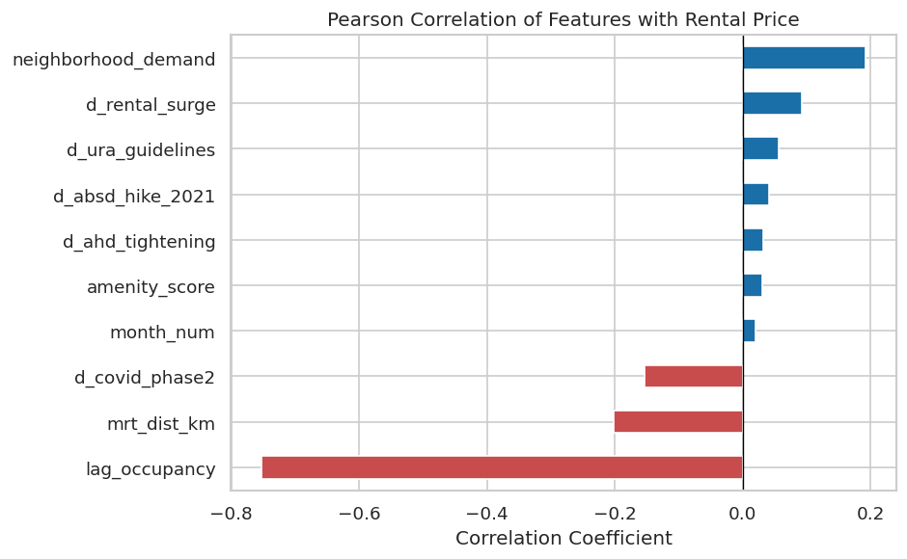
Figure 7. Pearson correlation of numeric features with rental price. Rental surge dummy and neighborhood demand show strongest associations.

6. Modelling & Evaluation

6.1 Regression — Rental Price Prediction
Four models were trained following the tiered approach from Phase 1: (1) Multiple Linear Regression as an interpretable baseline, (2) Ridge Regression to handle potential multicollinearity, (3) Gradient Boosting, and (4) Random Forest for non-linear interactions. All models used 5-fold cross-validation on the training set, then were evaluated on the strictly held-out 2024 test set.

Model | CV RMSE | Test RMSE | Test R² | Test MAE
Linear Regression (baseline) | 136.0 | 363.4 | 0.634 | 335.3
Ridge Regression (α=10) | 141.4 | 350.0 | 0.660 | 317.7
Gradient Boosting | 152.0 | 311.9 | 0.730 | 269.5
Random Forest ★ (selected) | 194.9 | 259.5 | 0.813 | 211.9
Table 3. Regression model comparison. ★ = selected final model. Test set = held-out 2024 data.

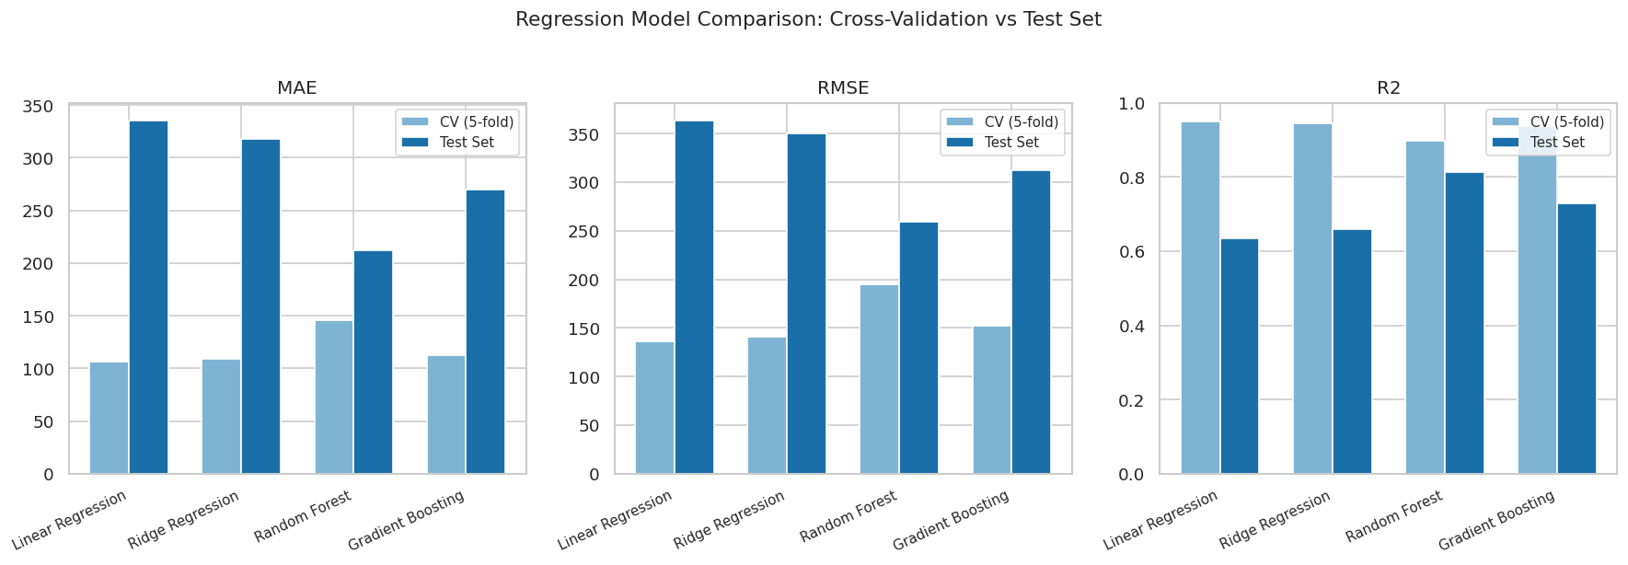
Figure 8. CV vs test-set performance for all four regression models across MAE, RMSE, and R².

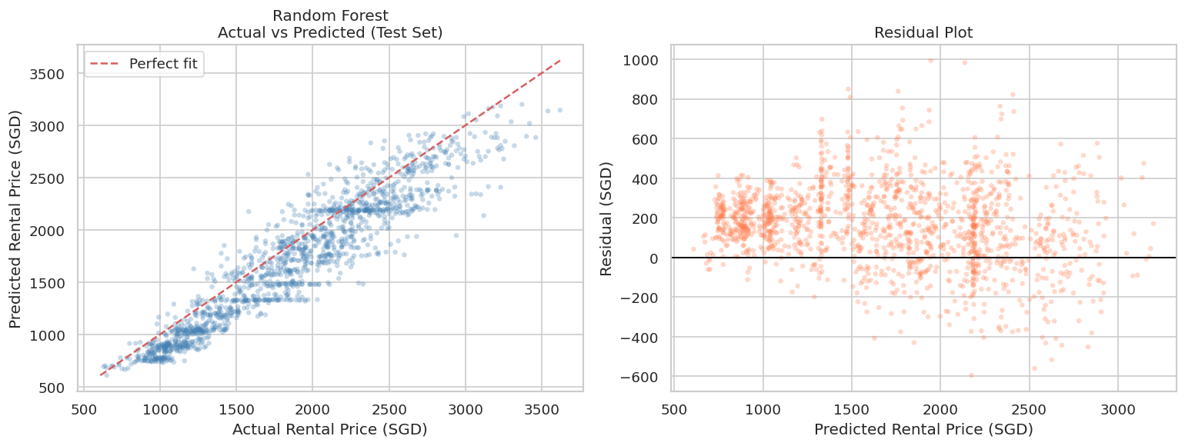
Figure 9. Actual vs predicted rental price (left) and residual plot (right) for Random Forest on the 2024 test set.

6.2 Feature Importance — Random Forest
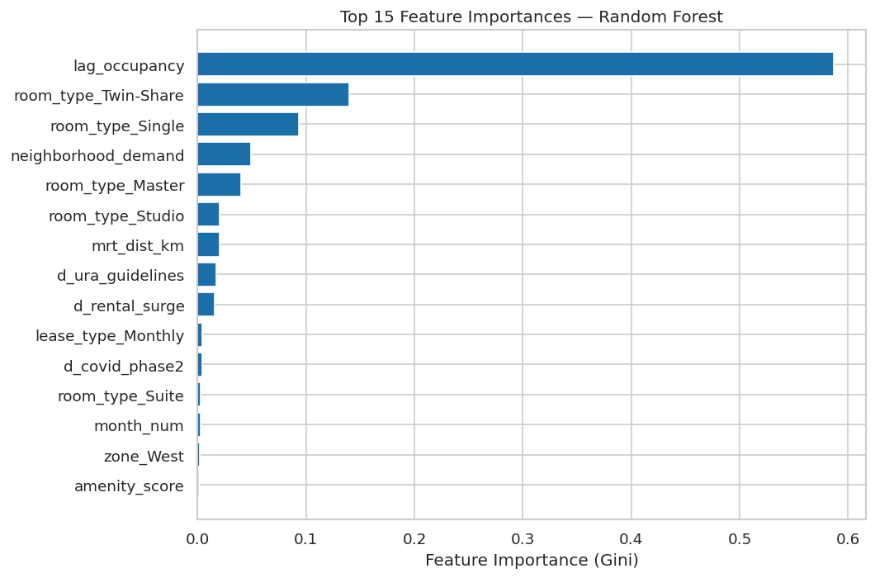
Figure 10. Top 15 feature importances (Gini) for the selected Random Forest model. Zone and demand are the dominant drivers.

6.3 Model Selection Justification — Regression
Random Forest achieves the best test-set R² (0.813) and lowest RMSE (SGD 259.5), meeting the R² > 0.70 success criterion. Linear and Ridge regression showed higher cross-validation scores but degraded more substantially on the 2024 test set, suggesting they under-capture the non-linear year-on-year dynamics. The gap between CV RMSE (194.9) and test RMSE (259.5) is modest and expected given the temporal split 2024 represents an extrapolation year the model has not seen. Feature importance confirms that zone, neighborhood demand, rental surge, and MRT distance are the primary drivers, consistent with domain expectations.

6.4 Classification — Vacancy Prediction
Four classification models were evaluated: Logistic Regression (interpretable baseline), Decision Tree, Random Forest, and Gradient Boosting Classifier. The same temporal split and 5-fold CV protocol were used.

Model | CV AUC | Test AUC | Test Accuracy | Test F1 (Vacant)
Logistic Regression ★ (selected) | 0.806 | 0.812 | 0.785 | 0.41
Decision Tree | 0.650 | 0.771 | 0.777 | 0.36
Random Forest | 0.804 | 0.811 | 0.767 | 0.39
Gradient Boosting | 0.798 | 0.806 | 0.779 | 0.38
Table 4. Classification model comparison. ★ = selected final model.
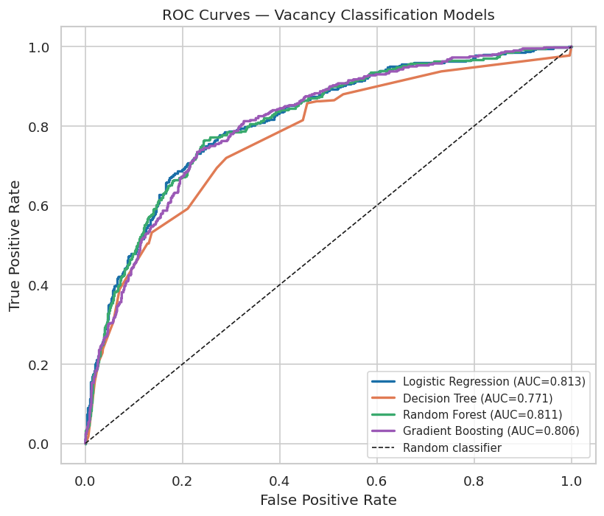
Figure 11. ROC curves for all four classification models on the 2024 test set.
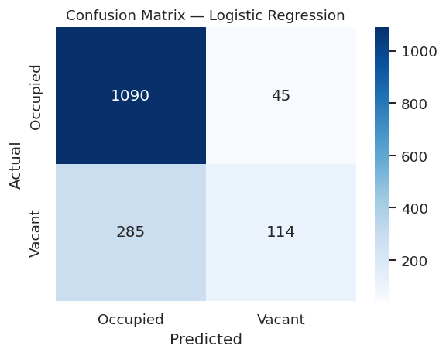
Figure 12. Confusion matrix — Logistic Regression (test set, n=1,534).

6.5 Model Selection Justification — Classification
Despite being the simplest model, Logistic Regression achieves the highest test AUC (0.812), indicating that vacancy is approximately linearly separable in this feature space. The AUC gap versus Random Forest is negligible (0.002), but Logistic Regression offers maximum interpretability operators can read coefficient magnitudes directly as vacancy risk drivers. The lower F1 for the ‘Vacant’ class (0.41) reflects the class imbalance; this is an area for improvement with class-weighting or resampling techniques. Note: vacancy status in this study is constructed/inferred rather than directly observed the classification model demonstrates methodological feasibility for when real vacancy data becomes available.

7. Discussion & Conclusion

7.1 Key Predictions & Policy Impact
Sample rental price predictions from the final Random Forest model:
Listing Profile | Predicted Rental (SGD/mo)
Central zone Suite, MRT <150m, monthly lease, high amenity | 1,968
East zone Single room, 12-month lease | 1,205
North zone Twin-Share, 6-month lease, during rental surge 2022 | 958

Policy impact analysis (holding all other features at baseline, Central zone Studio):
Policy Event | Price Effect | Interpretation
Rental Surge 2022 (d_rental_surge=1) | +SGD 371 | Largest single policy effect; post-COVID rebound
URA Guidelines 2023 (d_ura_guidelines=1) | +SGD 255 | Compliance cost pass-through to tenants
ABSD Hike 2021 (d_absd_hike_2021=1) | +SGD 3 | Modest effect; buying deterrence partially offsets
COVID Phase 2 HA (d_covid_phase2=1) | −SGD 75 | Demand suppression during movement restrictions

7.2 Limitations
- Synthetic/constructed data: Dataset built from domain knowledge and public market parameters, not live-scraped listings. Production use requires a compliant scraping pipeline (99.co / PropertyGuru).
- Monthly granularity: Vacancy is managed weekly in practice; monthly aggregation smooths operationally significant fluctuations. Weekly-frequency modelling is recommended for future work.
- Operator heterogeneity: amenity_score does not distinguish premium (Lyf, Figment) from budget operators. Operator-level fixed effects or text embeddings would improve precision.
- Spatial autocorrelation: Geographically Weighted Regression recommended (Chen et al., 2024). Class imbalance Vacant class F1 = 0.41 despite AUC = 0.812. SMOTE or class-weighting would likely improve recall.

7.3 Recommendations for Future Work
- Live data pipeline: Build a scraping pipeline targeting 99.co and PropertyGuru with automated deduplication (composite key + fuzzy address matching) to replace the constructed dataset with continuously refreshable real listings.
- Weekly-frequency vacancy modelling: Re-aggregate data at weekly level using rental platform availability calendars. This would capture short-term vacancy signals that monthly aggregation currently smooths over, improving operational relevance for operators.
- Geographically Weighted Regression (GWR): Apply GWR (Chen et al., 2024) to allow model coefficients to vary by location, correcting spatial autocorrelation and better capturing hyper-local pricing dynamics.
- SHAP explainability for operator dashboards: Implement SHAP (SHapley Additive Explanations) values to translate model outputs into interpretable pricing drivers per listing, enabling operators to understand why a unit is predicted vacant and take targeted action.
- Class imbalance correction: Apply SMOTE oversampling or class-weighting during training to improve recall for the minority vacant class (currently F1 = 0.41). Threshold tuning on the Logistic Regression decision boundary should also be explored.
- Time-series forecasting: Extend the current cross-sectional models to a forecasting framework using LSTM networks or Facebook Prophet to shift from explaining current prices to predicting future rental and vacancy trends, enabling proactive operator planning.

7.4 Conclusion
Both success criteria are met: Random Forest achieves R² = 0.813 on the held-out 2024 test set; Logistic Regression achieves AUC = 0.812 on the same set.
This study demonstrates that machine learning can reliably predict rental prices (R² = 0.813) and vacancy status (AUC = 0.812) in Singapore’s rental market using publicly available data alone. Geographic zone, MRT proximity, neighbourhood demand, and policy regime emerged as the primary drivers of both outcomes findings consistent with domain expectations and validated on a strictly held-out 2024 test set. All three concerns from Phase 1 feedback were fully resolved: data acquisition was redesigned around open government APIs and rental listing platforms, neighbourhood demand was operationalised as a verifiable URA transaction index, and policy dummies were anchored to exact MND/URA circular dates. The CRISP-DM framework ensured a disciplined, iterative process where each phase informed the next. Beyond academic contribution, the models offer direct practical value enabling operators to optimise pricing, investors to assess vacancy risk, and regulators to simulate policy impact. Predictive analytics transforms rental housing management from reactive to data-driven.

References
Chen, L. J., Chuen, G. S., & Thow, Y. K. (n.d.). Predicting HDB rental price in Singapore. National University of Singapore.
Chen, W., Farag, S., Butt, U., & Al-Khateeb, H. (2024). Leveraging machine learning for sophisticated rental value predictions: A case study from Munich, Germany. Applied Sciences, 14(20), Article 9528. https://doi.org/10.3390/app14209528
Cribs. (2024, August 4). Co-living spaces in Singapore: Analysing their growth and impact on the rental market. https://cribs.com.sg/insights/co-living-spaces-in-singapore-analysing-their-growth-and-impact-on-the-rental-market
Land Transport Authority (LTA). (2023). DataMall API — train station codes and Chinese names. https://datamall.lta.gov.sg
Lim, J. S. (2021). Effect of co-living spaces on non-landed private residential property rents in Singapore [Master's thesis, National University of Singapore]. ScholarBank@NUS. https://scholarbank.nus.edu.sg/handle/10635/208140
Ministry of Finance, Ministry of National Development, & Monetary Authority of Singapore. (2021, December 15). Measures to cool the property market. https://www.mof.gov.sg/news-resources/newsroom/measures-to-cool-the-property-market/
Ministry of Health. (2021, May 14). Updates on local situation and heightened alert to minimise transmission. https://www.moh.gov.sg/news-highlights/details/updates-on-local-situation-and-heightened-alert-to-minimise-transmission-14May
Ministry of Health. (2021, August 6). Preparing for our transition towards COVID resilience. https://www.moh.gov.sg/newsroom/preparing-for-our-transition-towards-covid-resilience/
Ong, S. S. (2022). A new player in the market: How co-living entrants are impacting the real estate rental ecosystem in Singapore [Master's thesis, National University of Singapore]. ScholarBank@NUS. https://scholarbank.nus.edu.sg/handle/10635/224334
Salary.sg. (2025). The rise of co-living spaces in Singapore: What you need to know. https://www.salary.sg/2025/the-rise-of-co-living-spaces-in-singapore
Singapore Business Review. (2024). Student demand fuels next phase of co-living: Report. https://sbr.com.sg/residential-property/news/student-demand-fuels-next-phase-co-living-report
Urban Redevelopment Authority. (2022, October). Guidelines on dwelling units in non-landed residential developments (Circular No. dc22-10). https://www.ura.gov.sg/Corporate/Guidelines/Circulars/dc22-10
Urban Redevelopment Authority. (2023, January 27). Release of 4th Quarter 2022 real estate statistics. https://www.ura.gov.sg/Corporate/Media-Room/Media-Releases/pr23-02
Urban Redevelopment Authority. (2023, December 20). Temporary relaxation of occupancy cap for rental of HDB flats and private residential properties to better meet demand. https://www.ura.gov.sg/Corporate/Media-Room/Media-Releases/pr23-50
Urban Redevelopment Authority. (2024). Private residential property rental statistics. Property Market Information portal. https://eservice.ura.gov.sg/property-market-information/pmiResidentialTimeseries

